CRUISING WITH THE HOUSE!
The Norwegian Sky ~ Destination: The Bahamas
September 1-4, 2017
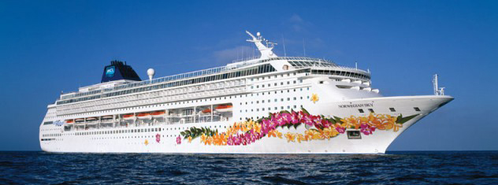
Join the women of The House of the Lord on a Rejuvenation Vacation as we sail into wellness during our annual Women’s Conference / Retreat.
REGISTRATION FORM
FULL NAME  (Name On Passport) | Click here to enter text.
ROOMMATE(S) | Click here to enter text.
STREET ADDRESS | Click here to enter text.
CITY / STATE / ZIP | Click here to enter text.
US CITIZEN? | Choose an item. | IF NO, NATIONALITY: Click here to enter text.
DATE OF BIRTH  (Month/Day/Year) | Click here to enter text. | GENDER: |  | Choose an item.
CELL PHONE | Click here to enter text.
EMAIL  (Required) | Click here to enter text.
CABIN CHOICE | ☐ Interior Double  $680/person | ☐ Oceanview Double  $780/person |  | ☐ Balcony Double  $900/person
All cabin prices are per person, double occupancy.
Inquire about single and triple rates
Monthly payment plan available
HOME CHURCH | Click here to enter text. |  | CITY: Click here to enter text.
Your fare includes: cruise fare, taxes & fees, prepaid gratuities, conference registration, conference bag & t-shirt, 3+ meals each day, on board activities & entertainment
What is not included: Transportation to/from port in Miami, on board purchases, and shore excursions.

TO REGISTER: PLEASE SUBMIT THIS FORM ALONG WITH NON-REFUNDABLE $150 DEPOSIT
PAYABLE TO “THE HOUSE OF THE LORD CHURCH.” Send to 415 Atlantic Ave, Brooklyn, NY 11217

Final Payment due May 30, 2017, NO EXCEPTIONS!
Cruise line cancellation policy: NO REFUNDS AFTER May 30, 2017.
NOTE: A VALID PASSPORT IS THE ONLY ACCEPTABLE PROOF OF CITIZENSHIP.

☐ I’d like information on travel protection insurance pricing. STRONGLY RECOMMENDED!
☐ I waive travel protection insurance.
Have you cruised with Norwegian Cruise Line in the past?
☐ Yes ☐ No Year: Click here to enter text.
PAYMENTS:
Checks, Money Orders, Visa, Master Card, AmEx
Bounced check fee $35. Checks will not be accepted after bouncing one!
For Credit Card Payments: Call Lynnee Porter at Cruise Planners/CruiseOne. 917-273-2321
For Checks: Mail to Lynnee Porter at 450 3rd Street, Suite 4R, Brooklyn, NY 11215
Email Address: lporter822@yahoo.com

Travel Agency: Cruise Planners in association with CruiseOne

